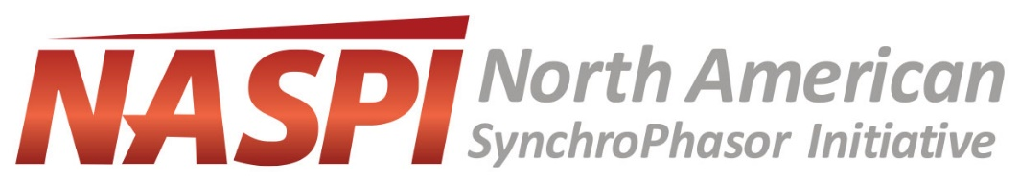

NASPI Work Group Meeting
October 23-24, 2018

The October NASPI Work Group meeting will be held in Philadelphia, Pennsylvania, on October 23-24, 2018.

Poster Session Success Stories: We would like to invite individuals who wish to present a poster at the NASPI Work Group meeting to send an abstract to naspi@pnnl.gov by August 31, 2018. The abstract needs to include a title, name of the presenter(s), affiliation, email address and a brief description of the poster. Optional template for the abstract provided below. The posters will be displayed the evening of October 23, 2018.

Poster Form

Poster Title:
Presenter(s)
Name:
Affiliation:
Email address:
Name:
Affiliation:
Email address:
Name:
Affiliation:
Email address:
Abstract:

