Categorizing Phasor Measurement Units by Application Data Requirements

Overview
Phasor measurement units (PMUs) are becoming prevalent on the power system, as is their integration into advanced power system applications. Performance characteristics for the PMU devices are formalized under IEEE Standard C37.118.1-2011 [1]. Formalizing the data requirements for PMU-based applications defines characteristics for utilizing these devices. Creating a set of consistent, quantifiable requirements for different applications of PMU data helps new and existing users understand the capability and suitability of PMUs in their particular scenarios. Understanding these requirements and limitations will help PMU data users determine potentially necessary infrastructure upgrades, as well as provide indications where existing PMU deployments can be leveraged.

While the C37.118.1-2011 standard handles many aspects of the actual device, application requirements are not as formalized. In 2008, working groups for the North American Synchrophasor Initiative (NASPI) created a table and document for “Phasor Data Classification” [2]. The high-level result of these documents is shown in Figure 1. The 2008 document condensed PMU data applications into four categories and five metrics. While an excellent start to defining PMU application requirements, the document is starting to show its age and needs to be refined.

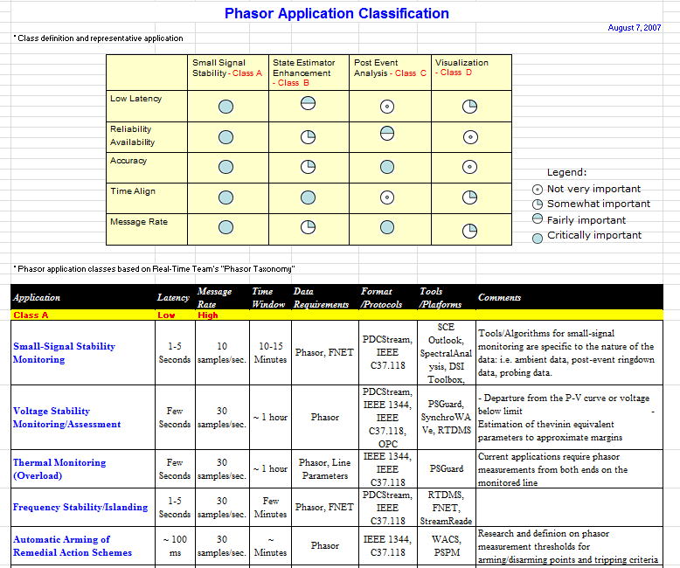
Figure 1: Summary table and details for 2008 Application Classification Document [2]

This document, and its corresponding Excel spreadsheet, represents the attempt to refresh the 2008 document set. A larger companion document, “NASPI Data Class Update”, is also being created within the NASPI working groups to cover more detail on the application requirements. This document is meant to provide a higher-level view of the requirements and focus more on specific requirement quantities in the table.

The corresponding Excel spreadsheet should be available as PMU_Application_Data_Requirements_2015_March.xlsx.

Application Data Metrics
This section provides some descriptions of the various columns of the corresponding Excel document. These quantities encompass various aspects of the phasor measurement unit usage, from direct data acquisition to communicating the data.

PMU Measurement Parameters
The first four metrics are focused on the acquisition characteristics of the power system phasor quantities.

Amplitude, Angle, or Frequency – This parameter is divided into two categories, precision and accuracy.
Precision: Level of detail (number of digits) specific applications require; e.g., frequency measurements with 0.01 Hz increments. Note that this will also be tied closely to CT/PT ratios and the connection of the device, but any overarching requirements should be stated here.
Accuracy: Indication of how well the measurement reflects the true system quantity, especially if it is beyond the requirements stated in the C37.118.1-2011 standard. If the values for Total Vector Error (TVE) stated within the standard are sufficient, fill this entry with “TVE”. Specific accuracy should be stated as a quantifiable value; e.g., within 1.0% voltage magnitude of the true value.

ROCOF – Rate of Change of Frequency – If an application requires a particular rate of change of frequency to properly function, this should be noted here. If the values stated within IEEE standard C37.118.1-2014a [3] are sufficient, put “STD” in this entry. While the ROCOF is stated in Hz/s, attempts should be made to quantify the interval the frequency measurement represents. E.g., 0.1 Hz/s for a frequency estimation interval of 1/60 of a second.

Frequency Range – Definition of the range or ranges of frequencies an application requires the data to represent. Note that this range represents behaviors in the captured phasor values, so it is subject to the frame sample rate. For example, a 20 Hz behavior cannot be captured without aliasing in a 30 frame/second PMU reading due to the Nyquist frequency being at 15 Hz. Values should be expressed in Hertz ranges of the electrical measurement. E.g., the application requires data in the 0.1 Hz to 0.9 Hz range.

Time Accuracy – Specific timestamp accuracy requirements for the application. If the ±26 μs value for 1% TVE stated within the IEEE C37.118.1-2011 standard is sufficient, fill this entry with “STD”. Specific values should be expressed in microseconds; e.g., samples should receive time-stamps that reflect ±15 μs of the actual sample time.

Delay/Quality Parameters
The second set of four metrics represents quantities to capture requirements associated with communication performance, data requirements, and sensitivities to dropped messages.

Measurement Transfer Time – Represents the maximum time from the event occurring on the power system to when the data must reach its final destination. This is “end-to-end” delay, from occurrence to the PMU acquisition, to the communication, to final decoding of the frame/packet. Note that while this document is focusing on application requirements associated with PMU data, this value may also lead to requirements on phasor data concentrator (PDC) timing. Values should be expressed in milliseconds; e.g., data frames must reach and be decoded in the central application within 16 ms of the power system event. This is an extension of “Information transfer time” from IEEE Standard 2030-2011[4].

Message Rate – Specific reporting rates required by the application. While closely tied to the frequency range metric in the previous category, this metric captures the bandwidth requirements of the application. Applications may require specific reporting rates for internal compliance or alarming. Values should be reported in reports per second; e.g., 30 reports per second. Reports are expected to follow C37.118.2-2011 [5] formatting and payload sizes. If the application has different report expectations, please indicate in the “Comments” field of the spreadsheet.

Time Window – Specific data ranges an application requires for proper operation. This may represent the typical integrating interval or analysis window of algorithms within the application and generally dictates the minimum amount of data retention required for the application. Values are expressed in seconds; e.g., application A utilizes a sliding window of 3600 seconds (1 hour).

Data Loss Sensitivity – Represents the maximum level of data lost an application can tolerate before failing. Data loss is categorized as corrupted packets, failure of delivery, or any other circumstance where the event data from the PMU does not reach the application. This may be tied closely to the message rate metric. This may also be related to measurement transfer time, as a failure to meet that transfer time could be represented as a data loss (e.g., PDC time alignment delays). Values should be expressed as either the number of reports or time interval before failure; e.g., application A generates an alarm and fails to converge if 30 frames are lost.

Other Information
The final category in the Excel table represents other considerations, existing deployments, and general comments for a specific application.

PMU Performance Class – PMU performance class is defined as the basic category to which the phasor measurement unit belongs. IEEE standard C37.118-2011 defines two classes: “M” class, for measurement devices; and “P” class, for protective devices. The largest difference between these classes is “P” classes often have a simplified filter on the phasor output stage. If an application can utilize either an “M” or “P” class PMU, a value of “X” for “don’t care” can be entered in this field. If the application has requirements that are not met by either the “M” or “P” class, a value of “N” for “New class” should be entered.

Tools/Platforms – Tools/platforms covers some example implementations of a specific application. This will be a named tool, commercial or educational, that performs the specific application and any platform requirements it requires.

Comments – This is a generic field for any future expectations, or noteworthy items that may not fit into the other categories. Caveats on the various requirements or notes on the values entered should be indicated in this field.

References
- IEEE Standard for Synchrophasor Measurements for Power Systems, IEEE Standard C37.118.1-2011, December 28, 2011.
- NASPI Contributors, “Phasor Application Classification”. [Online]. Available: https://www.naspi.org/File.aspx?fileID=604. August 7, 2008. Accessed October 12, 2014.
- IEEE Standard for Synchrophasor Measurements for Power Systems, IEEE Standard C37.118.1-2014a, March 27, 2014.
- IEEE Guide for Smart Grid Interoperability of Energy Technology and Information Technology with the Electric Power System (EPS), End-Use Applications, and Loads, IEEE Standard 2030-2011, September 10, 2011.
- IEEE Standard for Synchrophasor Data Transfer for Power Systems, IEEE Standard C37.118.2-2011, December 28, 2011.

Version/complimentary documents

Draft version of March 20, 2015 – Created by Frank Tuffner, Pacific Northwest National Laboratory
Minor update April 25, 2016
Released in conjunction with Excel spreadsheet “PMU_Application_Data_Requirements_2015_March_20160425ver.xlsx”.

Contributing edits and comments provided by:
Dave Bakken – Washington State University
Raymond Hayes – ESTA International, LLC
Anthony Johnson – Southern California Edison
Harold Kirkham – Pacific Northwest National Laboratory
Bill Wagner – Bonneville Power Administration

For further information, please contact Frank Tuffner at francis.tuffner@pnnl.gov.

